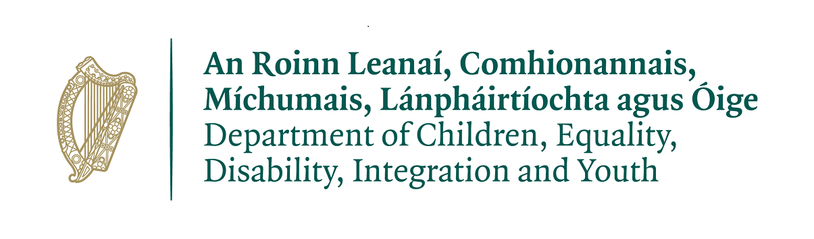

Targeted Youth Employability Support Initiative 2021/2022

Information Note For Applicant Organisations

The information contained in this document should be read in conjunction with the TYESI Application Form and Guidance Document.

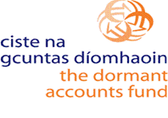
Information for Applicant Organisations – Frequently Asked Questions
What is the TYESI?
The TYESI is an acronym which stands for Targeted Youth Employability Support Initiative. The TYESI is intended to fund programme/actions to support young people aged 15-24 years who are not in employment education or training by providing community-based interventions to improve their soft skills, confidence and agency to ensure engagement by young people in progression pathways.

Who is eligible to apply?
The initiative is open to community, voluntary and not-for-profit services and organisations that support young people. Applications may be made by individual organisations. Joint applications are permissible, where a joint initiative is proposed, a lead organisation must be nominated as the responsible party for the application and all aspects of the Initiative.

What is the target group?
The target group for the TYESI is young people between the ages of 15 and 24 (inclusive), who are not currently in employment, education, or training. The purpose is to engage ‘hard to reach’ targeted young people, including young people experiencing isolation, economic disadvantage or intergenerational unemployment.

What is an ETB TYESI Needs Profile?
An ETB TYESI Needs Profile may be provided with your application. This is outline of the prioritised target group/s and/or geographic location/s that the ETB intends to be the primary focus of the interventions in the ETB functional area.

Applicant Organisations must respond to the ETB TYESI Needs Profile addressing the target groups & needs identified within same. When completing the application form, applicant organisations will clearly outline how the proposed programme/actions responds to the ETB TYESI Needs Profile.

What needs are to be addressed if the ETB does not issue an ETB TYESI Needs Profile?
Where ETBs do not issue an ETB TYESI Needs Profile, applicant organisations are expected to
respond to the needs of the TYESI target group. Identification of need should be supported by qualitative and quantitative data. (see ‘What is a target group?’ above.)

What approaches/actions are eligible under the TYESI?
Participation by young people will be on a voluntary basis. The overall approach should aim to engage with young people to develop their personal and social development outcomes and support young people by preparing them for onward progression to further education, training and/or employment. A community based, young person-centred support response to the needs of the target group should be evident. Mentoring and coaching must be incorporated into the service delivery.
How much funding is available?
Each ETB has been allocated an annualised budget for the TYESI. Each ETB will advertise the total amount available. A formal allocation will only be made following approval by the Department. The maximum funding allocation per individual project will not exceed the allocation available to the ETB or €60,000 whichever is the lesser amount.

What expenditure is eligible under the TYESI?
Direct and indirect costs are eligible expenditure under the TYESI. Direct costs refer to staff and programme costs. Indirect costs refer to rent, light, heat etc. Indirect costs must not exceed 10% of the total budget. If the total cost of the project is greater than the amount of the grant sought, the applicant must clearly outline the source of the balance of funding and how it will be secured. Duplication of funding is not permitted.

What is the duration of the funding under TYESI?
The scheme will operate for a minimum 12-month period. Funding for 2022 is subject to the annual budgetary processes taking place later this year. DCEDIY are currently working to secure funding to end of December 2022. This will be confirmed in early 2022. Taking cognizance of this all applications should be completed based on 12-month delivery and should not exceed the maximum grant allocation limit of €60,000.

Will there be a second round of applications for the TYESI for 2022?
The current application process outcome is valid for the period 2021 to end 2022. However, public financial requirements mean that allocations are annualised, i.e. an allocation will need to be formally provided in 2022 and a budget submitted to the ETB for review.

How can organisation/groups apply for funding?
Applicant organisation must fully complete the application form and submit to the ETB using the designated email by the closing date. Please be advised that incomplete application and/or applications received after the deadline will not be considered.

How are applications assessed?
Each ETB will convene an ETB Coordination Group to review all completed applications received by the deadline. The ETB Coordination Group will make recommendations to the DCEIDY based on the scoring system.

What are the criteria ETBs will use to recommended applications to the DCEDIY?
The criteria are as follows: Identified need, progression through partnership, soft skills, additionality and sustainability, mentoring and coaching & value for money. Applications must meet the minimum score requirement for each award criteria to be eligible for grant funding. In order to qualify for TYESI monies, applicants must score a minimum of 15 points in each individual category and clearly address the identified need.

What are the reporting requirements of the TYESI?
Successful organisations will be required to sign a Service Level Agreement with the relevant ETB & work in an open and collaborative manner over the course of the TYESI. All financial, operational and progress reports required for the TYESI must be submitted to the ETB. Any necessary changes to the service or expenditure as outlined in the application form must be agreed with the ETB.

Is there a prescribed measurement tool?
It is proposed to set a required measurement tool to use over the course of 2022. The prescribed measurement tool for the TYESI must be used by all successful applicants and the ETBs. This does not restrict successful applicant organisations from using a variety of other measurement tools suitable to their practice, project or the needs of young people.

Is there a national evaluation?
The DCEDIY plan to measure the success of the initiative by initiating a national evaluation of the TYESI in 2022. Engagement with the national evaluation of the TYESI will be required by all successful applicants and the 16 ETBs.

