Introduction to Kolb's Reflective Cycle
Kolb's Reflective Cycle, developed by David Kolb in 1984, is a learning theory that emphasizes the importance of reflection in the learning process. It suggests that experiential learning—learning from experience—occurs in a continuous cycle or spiral, helping individuals to understand their experiences, adapt, and apply what they have learned in future situations. Kolb's model is often used in education, training, and personal development to deepen learning and encourage growth through experience.
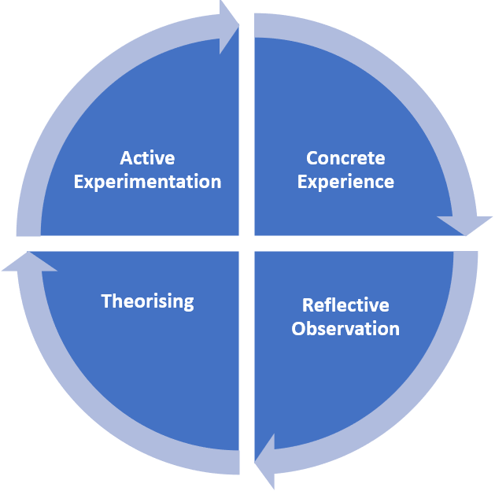

Explanation of Kolb's Reflective Cycle
Kolb's cycle consists of four stages that can be repeated as a continuous learning process:
1. Concrete Experience (CE)
- This is the stage where the learner has a direct experience.
- It’s when you “do” something and engage in an activity, task, or event.
- Example: Participating in a football match or trying a new technique in a sport.
This stage focuses on gaining experience, which forms the foundation for learning.
2. Reflective Observation (RO)
- After the experience, the learner reflects on it.
- They observe and think about what happened, what went well, and what didn’t.
- Example: Reflecting on your performance after the match, thinking about your decisions, actions, and the outcome.
In this stage, you take a step back and carefully analyse the experience to gain deeper insight.
3. Abstract Conceptualization (AC)
- At this stage, the learner makes sense of the experience by creating theories or concepts based on their observations.
- They generalize the learning and draw conclusions to improve future behaviour.
- Example: Learning that focusing on mental preparation before a match could improve performance next time.
This stage involves making connections, recognizing patterns, and drawing general conclusions from the experience.
4. Active Experimentation (AE)
- In this stage, the learner tests their new ideas or strategies in real-life situations.
- They apply what they've learned and experiment with different approaches to see what works best.
- Example: Implementing mental techniques, like breathing exercises or visualization, before the next match to see if it improves performance.
This stage involves actively testing out the conclusions drawn and applying them to new situations.

Why Use Kolb's Reflective Cycle?
- Promotes deep learning: Encourages learners to reflect thoroughly on their experiences and apply their insights.
- Encourages continuous improvement: By reflecting and experimenting, learners can improve and adapt over time.
- Supports practical application: The cycle focuses on real-world experiences, making learning immediately applicable.
- Helps develop critical thinking: Encourages individuals to analyse their actions and decisions more deeply.
- Adaptable to various contexts: Whether in education, healthcare, or sports, the model can be used to enhance learning and personal development.
Example of Kolb's Reflective Cycle in a Gym Scenario

1. Concrete Experience (CE)
I recently started a new strength training routine at the gym. It involved lifting heavier weights than I’m used to, with a focus on compound movements like squats, deadlifts, and bench presses. During my first session, I was unsure about my form but decided to push through and follow the routine as best I could.

2. Reflective Observation (RO)
After completing the workout, I reflected on how it went. I noticed I felt fatigued much quicker than expected, and some of my form (especially in the squat) wasn’t perfect. I also observed that I felt a bit discouraged at first but got more comfortable as I continued the session. My body felt sore the following day, and I wasn’t sure if the soreness was a sign of a good workout or if I had pushed myself too hard.

3. Abstract Conceptualization (AC)
Reflecting on the experience, I learned that proper form is key when lifting heavier weights to prevent injury and ensure I’m maximizing my results. I also realized that my body needs more time to adjust to this type of strength training, especially since I’m not used to lifting heavy. I concluded that gradually increasing the weights and focusing on form over time is a better approach. I also read that post-workout soreness is normal but should not interfere with my ability to recover or continue training.

4. Active Experimentation (AE)
For my next workout, I plan to start with lighter weights to work on my form. I will also focus on my breathing and posture, ensuring I don’t rush through movements. I’ll progressively increase the weight in future sessions but prioritize quality over quantity. I’ll also try adding rest days in between heavy workouts to allow my muscles to recover better.

Final Thoughts
By following Kolb’s Reflective Cycle, I can improve my gym workouts by continuously learning from my experiences, reflecting on them, and making adjustments to enhance performance and prevent injury. This process allows me to gradually build strength while ensuring my technique and recovery strategies are effective.

Gibbs Reflective cycle.
Introduction to Gibbs' Reflective Cycle
Gibbs' Reflective Cycle is a structured framework for reflection, developed by Graham Gibbs in 1988. It provides a systematic way to analyse experiences, particularly in learning and professional development. The cycle encourages individuals to think deeply about their experiences, assess their reactions, and plan for future improvements. It is widely used in education, healthcare, and professional training to enhance learning from both positive and negative experiences.
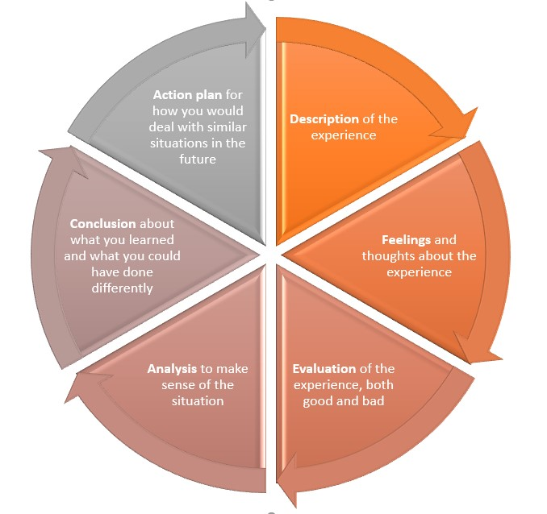
Explanation of Gibbs' Reflective Cycle
The cycle consists of six stages that guide an individual through the reflective process:
1. Description
- What happened?
- Who was involved?
- Where and when did it occur?
- What was the outcome?
This step provides a factual account of the experience without analysis or judgment.
2. Feelings
- What were you thinking and feeling at the time?
- How did the experience make you feel before, during, and after?
- How did others involved feel?
This step explores emotions and thoughts but does not evaluate them yet.
3. Evaluation
- What went well?
- What did not go well?
- Were there any positives from the experience?
- What were the challenges or negatives?
This step considers both the strengths and weaknesses of the situation.
4. Analysis
- Why did things happen the way they did?
- What factors contributed to success or failure?
- What theories or knowledge can help explain the situation?
This step helps to deepen understanding by connecting experiences to theories, principles, or external perspectives.
5. Conclusion
- What did you learn from this experience?
- What could you have done differently?
- How could you have improved the outcome?
This step summarizes key takeaways and identifies improvements for future situations.
6. Action Plan
- If faced with a similar situation, what will you do differently?
- What skills or knowledge do you need to develop?
- How will you implement the lessons learned?
This step focuses on future growth and applying insights to improve future performance.

Example of Gibbs' Reflective Cycle in a Sports Scenario
Let's apply Gibbs' Reflective Cycle to a football (soccer) match where a player missed a crucial penalty in an important game.

1. Description
I was playing as a striker in a high-stakes football match. In the final minutes, we were awarded a penalty that could have won us the game. I stepped up to take the shot, but I missed, and we ended up drawing the match. My teammates looked disappointed, and I felt like I had let my team down.

2. Feelings
At that moment, I felt extremely nervous as I walked up to take the penalty. My heart was racing, and I doubted myself. When I missed, I felt frustrated, embarrassed, and guilty. After the game, I kept replaying the moment in my head, feeling like I had let everyone down.

3. Evaluation
On the positive side, I had the confidence to take the penalty under pressure, which shows leadership. However, I did not prepare mentally, and my technique was off—I hesitated before taking the shot. I let the pressure affect me rather than focusing on my usual penalty-taking routine.

4. Analysis
Looking back, I think my nerves got the better of me. I rushed the shot instead of taking a deep breath and focusing on my technique. I also didn't practice penalties enough in training, which meant I wasn’t fully prepared for this high-pressure situation. Studies on sports psychology suggest that visualization and breathing exercises can help improve performance under pressure, which I had not considered before.

5. Conclusion
From this experience, I learned that mental preparation is just as important as physical training. I also realized that mistakes are part of the game and that I need to develop resilience rather than dwelling on failure.

6. Action Plan
To improve, I will:
- Practice penalties regularly in training
- Work on mental preparation, including breathing exercises and visualization techniques.
- Learn from professional footballers on how they handle high-pressure moments.
- Accept that mistakes happen and use them as learning opportunities instead of letting them affect my confidence.

Final Thoughts
By following this reflective process, I can turn this missed penalty into a valuable learning experience. Next time, I will be better prepared both physically and mentally, which will increase my chances of success.
Further Reading: See https://reflection.ed.ac.uk/reflectors-toolkit/reflecting-on-experience/gibbs-reflective-cycle

