Appendix A: Material to support delivery
(these resources will be hosted in the ETBI Digital Library and will be updated on an ongoing basis)

MIMLOs | Module Content  Topics/ units of learning | Suggested resources  Link to ETBI Digital Library  Home - ETBI FET Digital Library - ETBI Digital Library at Education and Training Boards Ireland, ETBI  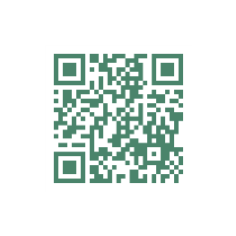
1 - 8 | Introduction to Nutrition  Determinants of Health and Impacts  Evidence-based Sources of Information | PowerPoint(s)
1-8 | Nutrition: Science and Everyday Application V2.0  Open Education Resource (OER) | PDF
8 | Food Pyramid | HSE PDF

