Module Title: Communications

Module Code: 3N0880

Module Level: Three

Assessment Technique: Collection of Work

1.1, 1.2, 1.3, 1.4, 2.2, 3.4 .3.5, & 3.6
Learning Outcomes:

Assignment Guidelines: As part of this assessment, you must attempt all aspects of the brief, that is, look at a headline and predict the content of the article and write in your journal, read the article, write your observations into your journal once again and share your thoughts with your small group, what five questions would your group ask of the author and write these down into your journal.

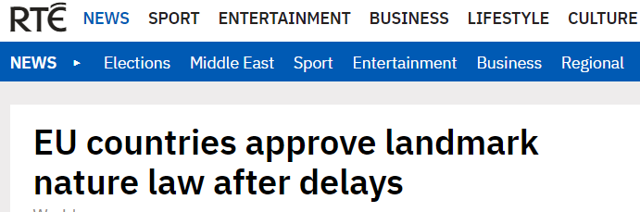

Assignment: Section Five: Media Article:

Step One: Look at the headline shown and predict what you believe the article is about. Write your prediction in your notes journal.
Step Two: Read the article.
Step Three: Write your observations in your notes journal and then share your thoughts in small groups.
Step Four: What 5 questions would your group like to ask the author of this article? Write the questions.

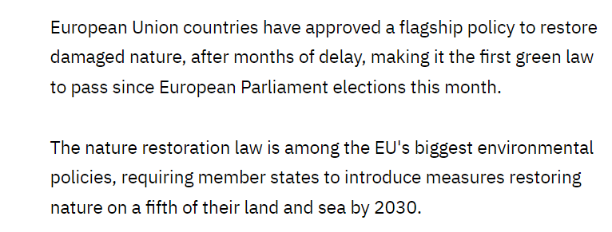

Assessment Criteria: | Maximum Mark | Learner Mark
All learning outcomes have been achieved | Successful

Feedback on learning:

