Module Title: Communications
Module Code: 3N0880
Module Level: Three
Assessment Technique: Collection of Work
1.1, 1.2, 1.3, 1.4, 2.2, 3.2 3.3, 3.5, 3.6 & 3.7
Learning Outcomes:

Assignment Guidelines: As part of this assessment, you must attempt all aspects of the brief, that is, research, compare and contrast two financial or health products, make notes to support your understanding in your notes journal, present a short informal presentation on your prepared product and finally, answer questions from your class group.

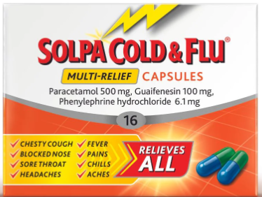

Assignment: Section Four: Health or Financial Research:

Step One: Research, compare and contrast two financial or health products, for example two savings accounts, flu medicines etc.
Step Two: Make notes to support your understanding in your notes journal
Step Three: Prepare and give a short, informal 2-3 minute presentation to your group explaining which product is the better option in your opinion.
Step Four: Answer questions from the audience. (Everyone must ask one question of the presenter.)

Assessment Criteria: | Maximum Mark | Learner Mark
All learning outcomes have been achieved | Successful

Feedback on learning:

