Module Title: Communications
Module Code: 3N0880
Module Level: Three
Assessment Technique: Collection of Work
1.1, 2.1, 2.3 & 3.3

Learning Outcomes:

Assignment Guidelines: As part of this assessment, you must attempt all aspects of the brief, that is, set up a demo social media account, take a video of you explaining the steps taken to set up this account, create a comic strip with screen shots or snips of each step you took to set up this demo account, write about each screen shot or snip you took to explain the steps you took to do this. Present your completed comic strip to the class informally through a discussion or ‘show and tell’ of how you set up a social media account and finally reflect and accept feedback on the process.

Step One: Set up a demonstration social media account, this can be an account of your choice.
Step Two: Take a video of you creating this account, this could be by using your phone to explain the steps.
Step Three: Take Screen Shots/Snips of the process of setting up the account to use in a comic strip. You can use your own template or software, such as, Canva.
Step Four: Write about the steps taken in setting up a social media account for your comic strip
Step Five: Present comic strip to group of how you set up a social media account, this should be informally.
Step Six: Reflect and accept feedback on the process

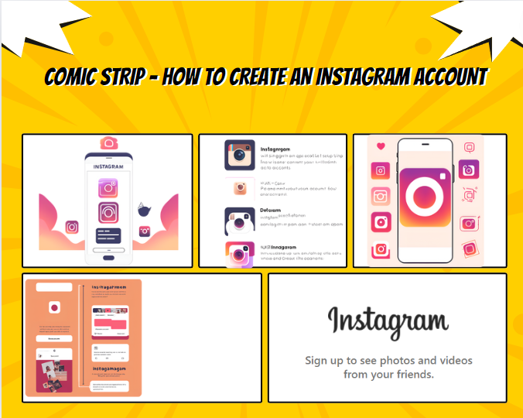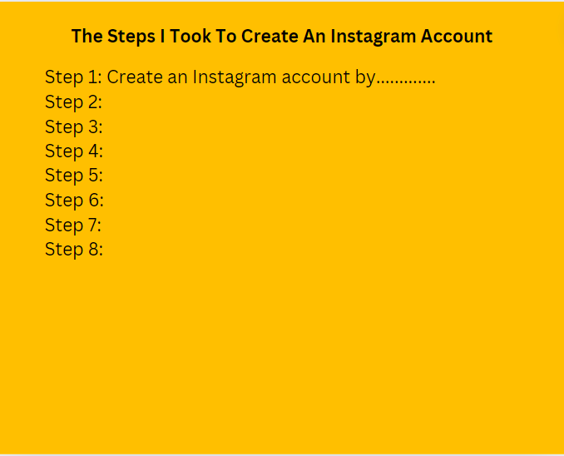

Assessment Criteria: | Maximum Mark | Learner Mark
All learning outcomes have been achieved | Successful

Feedback on learning:

