
Level 3

3N0929
Workbook

Overview for Level 3 Mathematics
This module is divided into 5 sections:
- Number pg.5 – pg.11
- Measurement and Capacity pg.14 – pg.19
- Algebra pg.22 – pg.25
- Data Handling pg.28 – pg.31
- Problem Solving pg.34 – pg.40
Multiplication Square and Table pg. 41 & Pg. 42

Assesment Technique: Collection of Work 100%
- Show your rough work but make sure the final answer or answers are clear.

- Rough work must be included with the portfolio.

- Always include the correct unit with your answer. For example, Km, m, €.
- If you are using a formula, write the formula before you do the calculations.

- Your answer or answers must be returned in their simplest form.
- All questions in this workbook must be answered fully.

Learner Name:

Section 1
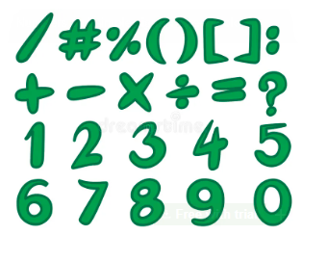
NUMBER

Module Title: Mathematics Level 3
Module Code: 3N0929
Assessment Technique: Collection of Work
Assessment: Brief 1 of 5
LOs: 1.1, 1.2, 1.3, 1.4, 1.5
Title: Number

Guidelines:
You will be expected to:
1.1 Explain the concept of natural numbers (N), integers (Z), and real numbers (R).
1.2 Demonstrate equivalence between common fractions, simple ratios, decimals, and percentages by conversion.

1.3 Give approximations by using strategies including significant figures and rounding off large natural numbers

1.4 Use a calculator to perform operations requiring functions such as +, -, ×, ÷, memory keys and clear key

1.5 Demonstrate accuracy of calculation by applying the principal mathematical functions, i.e. +, -, ×, ÷, natural numbers (N), integers (Z) and real numbers (R), simple fractions, and decimal numbers to two places of decimal

Assessment Criteria:
- Complete any written work as neatly as possible.
- Complete all parts of the brief.
- Answers to be returned in their lowest form.

I confirm that this is my own work.

Signed: ______________________ Date:______________

LO 1.1
Explain the concept of natural numbers (N), integers (Z) and real numbers (R).
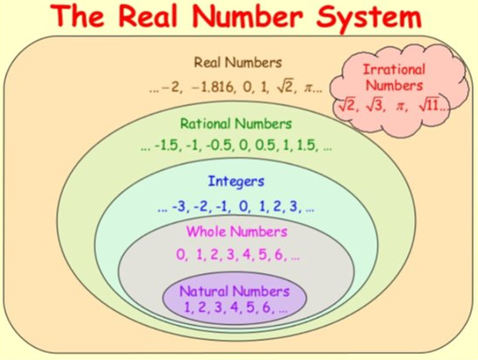

- Answer the questions about the number systems:

What is a natural number? Give an example.
__________________________________________________________________________________________________________________________________

EXAMPLE:
What is an integer? Give an example.
__________________________________________________________________________________________________________________________________EXAMPLE:

What is a real number? Give an example.
__________________________________________________________________________________________________________________________________EXAMPLE:

- Identify at least three areas in life you might need to use integers.
___________________________________________________________________________________________________________________________________________________________________________________________________
- Using the integer (Z) number line below complete the following calculations:

- 1 – 5 =
- -2 + 7 =
- 6 – 7 =
- -5 + 8 =
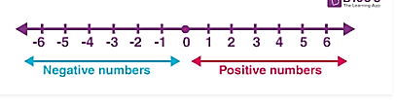

- Identify at least 3 areas in life you might need to use real numbers (fractions and decimals)
__________________________________________________________________________________________________________________________________________________________________________________________________________________________________________________________________________________________________________________________________________________________________________________________________________________________

- Using the number lines, identify where the following real numbers are placed:
$$\frac{1}{2}$$

$$\frac{1}{4}$$

$1\frac{1}{2}$

$$-0.75$$

$$\frac{5}{2}$$

LO 1.2, 1.4, 1.5
Demonstrate equivalence between common fractions, simple ratios, decimals, and percentages by conversion.

There are 8 images in the table below. Identify the fraction, decimal, percentage and ratio for each one. The first one is done for you. You can use your calculator to help convert each one.
Image | Fraction | Decimal | Percentage | Ratio
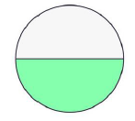 | $$\frac{1}{2}$$ | 0.5 | 50% | 1:2
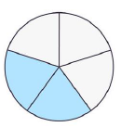 |  |  | 40%
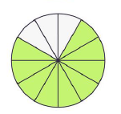 |  | 0.75
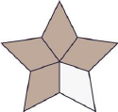 |  |  |  | 4:5

Image | Fraction | Decimal | Percentage | Ratio
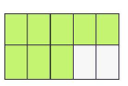 |  |  | 80%
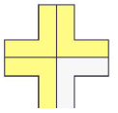 |  | 0.75
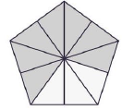 |  |  |  | 7:10
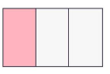 | $$\frac{1}{3}$$

LO 1.3, 1.4, 1.5
Give approximation by using strategies including significant figures and rounding off large natural numbers.
- Rounding
Use your calculator to add or subtract each number and round your answer to the required digits
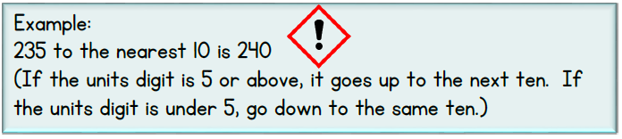
(a)

 | Calculation | Round numbers to the nearest 10
17 + 36
901 - 55
833 + 26

 | Calculation | Round numbers to the nearest 100
789 - 245
271 + 127
199 + 76
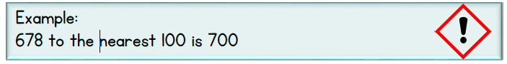
(b)

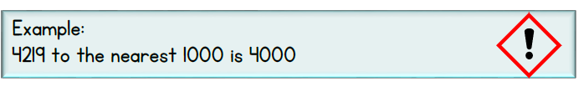

 | Calculation | Round to nearest 1000
1108 - 478
4689 + 7098
9283 + 4902
(c)
- Significant Numbers
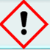
Example
1.57 m to 2 significant figures
1.57 has 3 significant figures, look to the third number which is 7, if this number is 5 or above add one to the second number.
Answer: 1.6 m (2 SF)

- Write 21. 3 to two significant places.

- Write 6.9 to one significant place.
- Use your answers from (a) and (b) to estimate the value of $\frac{21.3}{6.9}$

$\frac{21.3}{6.9}$ is approximately equal to =

- Use your calculator to find the exact value of $\frac{21.3}{6.9}$ correct to four significant figures.
Answer:

Section 2
Measurement &
Capacity
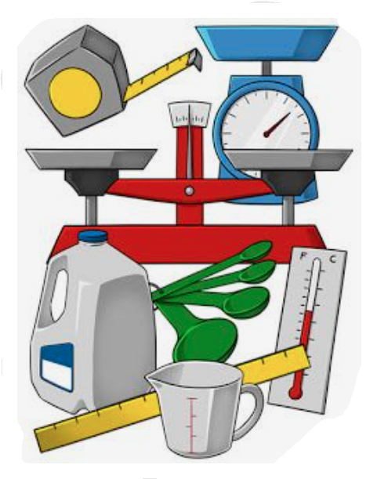

Module Title: Mathematics Level 3
Module Code: 3N0929
Assessment Technique: Collection of Work
Assessment: Brief 2 of 5
LOs: 2.1, 2.2, 2.3, 2.4, 2.5, 2.6, 1.4, 1.5
Title: Measurement & Capacity
Guidelines:
You will be expected to:
2.1 Describe shape and space constructs using language appropriate to shape and space to include square, rectangle, circle, cylinder, angles, bisect, radius, parallel, perpendicular
2.2 Draw everyday objects to scale using a range of mathematical instruments.

2.3 Calculate the area of square, rectangle, triangle, circle, by applying the correct formula and giving the answer in the correct form.

2.4 Calculate the volume of a cylinder and cone using the correct formula and giving the answer in the correct form

2.5 Demonstrate metric measurement skills using the correct measurement instrument, and vocabulary appropriate to the measurement, to accurately measure length/distance, capacity, weight, time

2.6 Use simple scaled drawings work out real distance, location and direction

  - Use a calculator to perform operations requiring functions such as +, -, ×, ÷, memory keys and clear key

  - Demonstrate accuracy of calculation by applying the principal mathematical functions, i.e. +, -, ×, ÷, natural numbers (N), integers (Z) and real numbers (R), simple fractions, and decimal numbers to two places of decimal

Assessment Criteria:
- All drawings are to be hand drawn with the correct scale identified.
- Label shapes using their correct name.
- Return answers in their lowest form.
- Write formulas before attempting the calculations.
- Ensure answers are clearly identified.
I confirm that this is my own work.
Signed: ______________________ Date:______________
LO 2.1
In the image below there are lots of geometric shapes that you are familiar with. Using arrows, identify the following shapes from the image.
- Square
- Rectangle
- Circle
- Cylinder
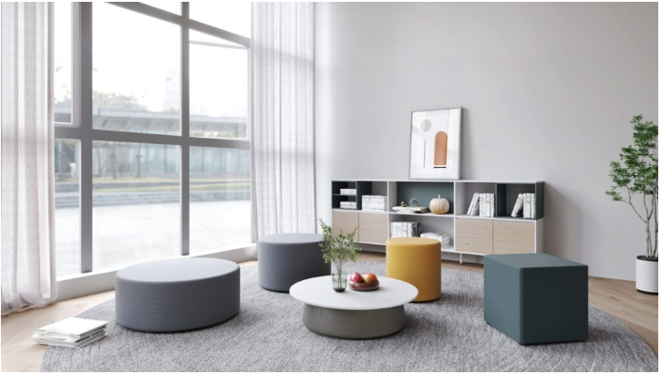

image courtesy of:1http:fabdiz.com

LO 2.1
Name the shape from the clues and identify the formula to measure the area (2D) and volume (3D):
Clues | Name of Shape and Formula
- I am a 2D shape  - I have four straight edges  - All my sides are equal  - I have four vertices  - I have four interior angles that are right angles and add up to 360 degrees | Name:  Area Formula:
- I am a 2D shape  - I have 0 corners  - The word circumference is used to measure my perimeter  - The radius is half the diameter of this shape | Name:  Area Formula:
- I am a 2D shape  - My opposite sides are parallel and are equal in measure  - The diagonals bisect each other and are both the same length  - I have four interior angles that are right angles and add up to 360 degrees | Name:  Area Formula:
- I am a 3D shape  - I have two identical circular faces at each end  - I have one curved side  - I do not have any edges | Name:  Volume Formula:

LO 2.2, 2.3, 2.5, 2.6, 1.4, 1.5
Design a scaled map of a park area and insert different shapes to include a circle, square, rectangle, and triangle.
When drawing your map use a range of mathematical instruments such as a ruler, compass, protractor, set square. Use colour to help identify the various shapes, pathways and arrows.
The scale will be 1cm = 1 m
On graph paper draw the layout of the park using the given scale. Ensure the park fits withing a 20 cm x 20 cm area on the graph paper.
Drawing Shapes to Scale:
- Draw a circular pond with a diameter of 4 metres.
- Draw four square benches measuring 2 m x 2 m
- Draw a rectangular play area measuring 6 m x 4 m.
- Draw a triangular sand pit with a base of 6 m and a height of 4 m.
Calculate the Area of each Shape and show all workings:
- Circular pond: $π$r²
- Four square benches: l x b
- Rectangular play area: l x b
- Triangular Sand Pit: $\frac{1}{2}$ base x perpendicular height$\left(⟂\right)$

Additional Details:
Distance
Draw at least two paths connecting different areas of the park. Measure the distance of each one using the scale.
Answer:
Using arrows, show how to get from point A to point B on your map. For example, you can show how to get from the entrance of the park to the play area.
Time:
Estimate how long it would take to walk the distance of one of the paths. Track the distance using a stopwatch/phone and note the difference between your estimate and how long it actually took you.
Answer:
Estimate
Actual:
Difference:

Weight:
Calculate the total weight of all four benches if each bench weighs 10.5 kgs.
Answer:

Capacity:
Calculate the capacity of the circular pond if it is 1.5 metres deep. Use the formula $π$r²h to find the volume and convert your answer to cubic litres
( 1 cubic litre = 1000 litres). Return your answer to two decimal places.
Answer:

LO 2.4, 1.4, 1.5

Calculate the volume of a cylinder by applying the correct formula. The answers are to be returned in the correct unit form. Use the $π$ button on your calculator and return your answer to 2 decimal places.
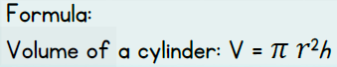
Volume of a Cylinder
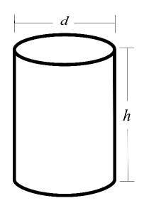

If h = 13 cm and r = 6 cm If h = 10 m and d = 4 m

If h = 11 m and r = 3m If h = 13 mm and d = 10 mm
LO 2.4, 1.4, 1.5
Volume of a Cone
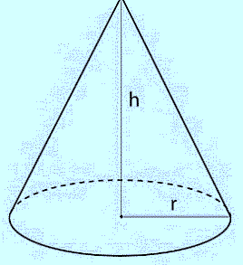
Calculate the volume of a cone by applying the correct formula. The answers are to be returned in the correct unit form. Use the $π$ button on your calculator and return your answer to 1 decimal place.
$\frac{1}{3}$ $π$ r²h

If h = 20 cm and r = 12 cm If h = 17 m and d = 8 m

If h = 18 mm and r = 10 mm If h = 25 mm and d = 12 mm

Section 3
Algebra
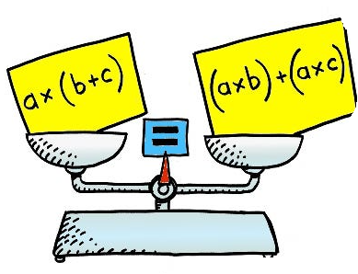

Module Title: Mathematics Level 3
Module Code: 3N0929
Assessment Technique: Collection of Work
Assessment: Brief 3 of 5
LOs: 3.1, 3.2, 3.3, 1.4, 1.5
Title: Algebra
Guidelines:
You will be expected to:
3.1 Describe familiar real life situations in algebraic form

3.2 Simplify basic algebraic expressions by applying the principal mathematical functions, i.e. +, - x and ÷ to algebraic expressions of one or two variables, e.g. 2a+3a, (9a+4b) (6a+2b), 2x-¹/₂-4x+²/₃+¹/₃

3.3 Solve simple algebraic equations of 1 variable, by using the variable to solve mathematical problems where the solution is N

1.4 Use a calculator to perform operations requiring functions such as +, -, ×, ÷, memory keys and clear key

1.5 Demonstrate accuracy of calculation by applying the principal mathematical functions, i.e. +, -, ×, ÷, natural numbers (N), integers (Z) and real numbers (R), simple fractions, and decimal numbers to two places of decimal

Assessment Criteria:
- All workings must be shown.
- All parts of the brief much be clearly and neatly completed.
- The correct order of operations must be followed.
- Use correct mathematical vocabulary.

I confirm that this is my own work.

Signed: ______________________ Date:______________

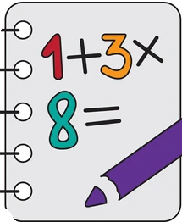
LO 3.1
Describe familiar real life situations in algebraic form
EXAMPLE
Mark’s phone plan costs €10 per month and €0.05 for every text message he sends. Let t represent text messages.
Write an algebraic expression that represents the cost of the plan.
10 + 0.05t = C

Write the following real life situations in algebraic form:
- Brenda’s job pays her a base salary of €450 per week plus €25 for every hour of overtime she works. Let h represent the number of overtime hours.
Question: Write an algebraic expression that represents her take home pay.

- Each pack of pencils cost €4 and each notebook costs €2. If you buy p packs of pencils and n notebooks, what is the total cost?
Question: Write an algebraic expression to represent the total cost.

- Angela goes to the cinema at the weekend with a friend and four children. The cost of an adult ticket is €9 and cost of a child’s ticket is €4. Angela wants to calculate the total cost of entry to the cinema for two adults and four children.
Question: Write an algebraic expression to help Angela work out the cost. Let a = adult, c = child and y = cost.

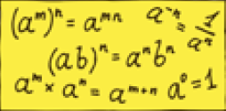

- Davidus has saved €29 towards a new game. The total cost of the game is €70.
Question: write an algebraic expression to help Davidus figure out how much more he needs to buy the game. Let x represent the unknown amount.

- Jim made a withdrawal of d euro from his savings account. His old balance was €750 and his new balance is €420.
Question: write an algebraic expression that shows Jim’s new balance

- Paula is x years old. In ten years’ time she will be twenty one years old.
Question: write an algebraic expression to show Paula’s age in ten years’ time.

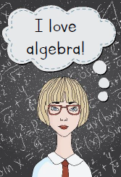

LO 3.2, 1.4, 1.5
Simplify basic algebraic expressions by applying the principal mathematical functions to algebraic expressions of one or two variables.
EXAMPLE
When simplifying an algebraic expression you can only add terms that are the same, In the example below we have two different terms, x and y. Gather the x terms together first and then the y terms. Add and subtract the terms that are the same leaving your answer on one line.

2x + 5y +3x – 2y

2x + 3x + 5y – 2y
Answer: 5x + 3y

- 12a + 3b + a – 2b

- 2ab + 7c + 3ab – 8c

- 4x + 3y – 3 + 3x + 6y + 7

- 2(4x + 3y – 6) + 5x – 2y + 5

- 6x – $\frac{1}{2}$ – 3x + $\frac{2}{5}$ + $\frac{3}{5}$

LO 3.3, 1.4, 1.5
Solve simple algebraic equations of 1 variable, by using the variable to solve mathematical problems where the solution is N (natural number).
EXAMPLE:
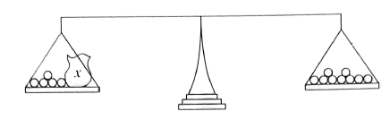
Consider the scales below. On the left side there is a bag containing an unknow number of marbles and five loose ones. On the right side there are nine marbles.

Let x stand for the unknown number, we could write the problem as
x + 5 = 9
If we take 5 from both sides of the equation we get:
x + 5 – 5 = 9 – 5
Answer: x = 4
When we find the value of x in an equation, we are said to have solved the equation.
Solve the following equations:
- x + 3 = 10

- x – 5 = 11

- x + 8 = 7

- 2x = 10

- 5x = 25


Section 4 Data Handling

Module Title: Mathematics Level 3
Module Code: 3N0929
Assessment Technique: Collection of Work
Assessment: Brief 4 of 5
LOs: 4.1, 4.2, 4.3, 4.4
Title: Data Handling

Guidelines:
You will be expected to:
  - Describe the presence of data in everyday situations.

  - Conduct a simple survey using a variety of data collection methods.

  - Display data using appropriate classifications on bar charts or pie charts.

4.4 Describe findings, to includes interpretation of results, and suggesting reasons for findings.

  - Use a calculator to perform operations requiring functions such as +, -, ×, ÷, memory keys and clear key

  - Demonstrate accuracy of calculation by applying the principal mathematical functions, i.e. +, -, ×, ÷, natural numbers (N), integers (Z) and real numbers (R), simple fractions, and decimal numbers to two places of decimal

Assessment Criteria:
- Complete any written work as neatly as possible.
- Attach a copy of the following:
  - A copy of the questions that you will be using in your survey
  - The table used to organise your data
  - A drawn copy of the bar chart.
- This assessment can be presented using PowerPoint or Canva if required.
I confirm that this is my own work.

Signed: ______________________ Date:______________

LO 4.1
Describe the presence of data in everyday situations.
Highlight the correct answer relating to data in everyday situations. There may be more than one answer.
1. Which of the following is an example of data in grocery shopping?
a) The number of steps you walk each day.
b) The price of apples over time.
c) The amount of money shoppers spend over a period of time.
d) The movies you watch in a week.

2. When looking at weather reports, what kind of data is often shown?
a) The number of books you read.
b) The temperature each day.
c) The amount of money you spend.
d) The time you spend watching TV.


3. In school, which of the following is an example of data?
a) The colour of your backpack.
b) The number of students present each day.
c) The type of shoes you wear.
d) The songs you listen to on your way to school.

4. Which situation involves collecting data about food preferences?
a) Counting the number of cars on a street.
b) Asking friends about their favourite fruits.
c) Measuring the height of plants.
d) Recording the time the sun sets each day.

5. Which of these is an example of data in sports?
a) The type of ball used in a game.
b) The score of each game played.
c) The colour of the team uniforms.
d) The day of the week the game is played.

6. In a school cafeteria, what data might be collected?
a) The types of shoes worn by students.
b) The number of each type of lunch sold.
c) The colours of lunch trays.
d) The books students bring to lunch.

7. Which of the following is an example of primary data?
a) Reading an article about the weather.
b) Asking your friends about their favourite sports.
c) Looking up population numbers on a website.
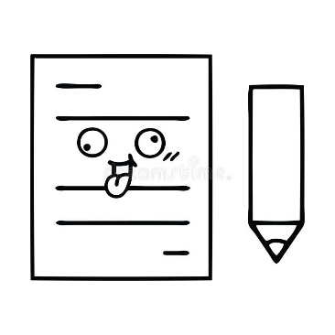
d) Reading a book about history.

8. Which of these is an example of secondary data?
a) Conducting an interview with a local business owner.
b) Counting the number of birds in your backyard.
c) Using the census to find employment statistics.
d) Taking a survey of what snacks people like.

LO 4.2, 4.3, 4.4, 1.4, 1.5
Criteria | Tasks | Details
LO 4.2
Conduct a simple survey using a variety of collection methods. | - Choose a survey topic  - Develop survey questions  - Collect responses | Example topics:  Favourite leisure activities  Preferred types of music/band/singer  Create 5-10 questions to include: yes/no, multiple choice and open ended questions.  Gather a minimum of 20 responses. These can be gathered using face-to-face, online or paper methods.
LO 4.3
Display the data using appropriate classifications on bar charts or pie charts. | - Categorise the data  - Choose presentation method  - Create chart | Review the responses to your survey and put them into a table.  Choose either a bar chart or pie chart to present your findings.  Label your chart correctly to include a title and axis labels.
LO 4.4
Describe findings, to include interpretation of results, and suggesting reasons for findings. | Interpret the results and suggest reasons for findings. | Use your chart to answer the questions on the next page.

Describe findings, to include interpretation of results, and suggesting reasons for findings.

- What category had the highest number of responses?

- What category had the lowest number of responses?

- What is the total number of responses?

- Calculate the percentage of responses for each category to the nearest whole number.

- What is the difference between the highest response and lowest response?

- Are there any similarities between categories?

- Do you think the data collected was reliable? Why or why not?

- What improvements would you suggest for future surveys to ensure the data is reliable and accurate?


Section 5
Problem Solving


Module Title: Mathematics Level 3
Module Code: 3N0929
Assessment Technique: Collection of Work
Assessment: Brief 5 of 5
LOs: 5.1, 5.2, 5.3, 1.4, 1.5
Title: Problem Solving
Guidelines:
You will be expected to:
5.1 Describe everyday situations in terms of quantitative descriptions.

5.2 Calculate solutions to real life quantitative problems by applying appropriate mathematical techniques.

5.3 Describe how a quantitative solution to a problem may be applied in a limited range of contexts.

  - Use a calculator to perform operations requiring functions such as +, -, ×, ÷, memory keys and clear key

  - Demonstrate accuracy of calculation by applying the principal mathematical functions, i.e. +, -, ×, ÷, natural numbers (N), integers (Z) and real numbers (R), simple fractions, and decimal numbers to two places of decimal

Assessment Criteria:
- All calculations must be accurate to two decimal places.
- All workings must be shown.
- Your workings and answers must be clearly and neatly presented.
- Use correct mathematical vocabulary.
- Answers must be in their simplest form and be accompanied by the appropriate unit.

I confirm that this is my own work.

Signed: ______________________ Date:______________

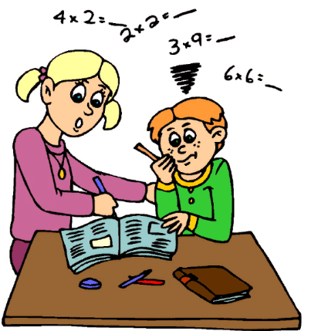
LO 5.1
Everyday Problem Solving
Give at least 5 examples of everyday situations where maths can be used to solve problems.

1.
2.
3.
4.
5.

LO 5.2, 1.4, 1.5
Everyday Problem Solving
Calculate the solutions to these real-life problems by using different mathematical techniques and your calculator.
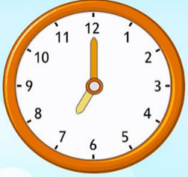
- Marcus needs to be at work by 9:00 am. It takes him 25 minutes to prepare for the day ahead, 5 minutes to warm up his car and 45 minutes to drive to work. What time should he set his alarm for in order to get to work on time?

- Change this recipe for 4 people to a recipe for 6 people. Show your workings below.
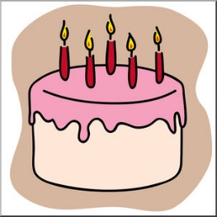
Recipe for 6
Sponge Cake

Recipe for 4
Sponge Cake
Water 300 ml
Butter 120 g
Sugar 160 g
Flour 240 g
Eggs 2


- Kim saved €24.25 in January, €17.80 in February, and €37.90 in March. She wants to buy a new speaker that will cost €95. How much money does she need to make this purchase? Show your workings below.

- Anastasiia and her family went to London on holidays. They hired a car for a week . The cost of hiring the car for 7 days was €85 per day, plus VAT at 15%. Find the total cost of hiring the car for the week.

7 days @ €85 per day= | €
VAT @ 15% = | €
Total Cost= | €


- Sam bought 20 posters for his business. He paid €8 for each poster. If 23% VAT was added to the total cost, and he had to pay €9.95 for postage, how much was his total bill? Show your workings below.
20 posters @ €8 each = | €
VAT @ 23% = | €
Postage = | €
Total Cost = | €


- Simon was trying to save up €350 for a holiday. He earns €14 an hour and works 35 hours per week. After paying for his weekly expenditure he finds he can only save $\frac{1}{10}$ of his weekly earnings. How much money will he need to save each week for his holiday to the nearest number of weeks? Show all of your workings.

- James developed a game for phones that he sold for €1. After the first week, he found that he had 4632 downloads from females and twice as many from males. Of the males that downloaded it, only $\frac{1}{8}$ bought the full game. How many males bought the full game? Show all your workings

- A group of 5 friends decide to save for a weekend trip. They plan to save a total of €1250. They agree to contribute equally. How much does each person need to save?

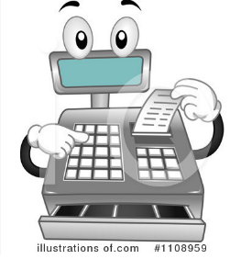
- A restaurant bill is €390 plus VAT @ 23%. The bill is divided between 12 friends. How much does each friend pay? Round your answer to the nearest euro. Show your workings.

- Four siblings inherit a piece of land from their grandparents. The total area of the land is 3600 m². They decide to divide the land equally among themselves. How much land does each sibling get?
Show your workings.
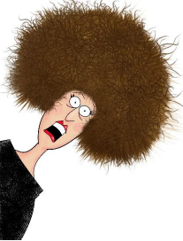

LO 5.3, 1.4, 1.5
Problem solve to find the answers to the questions:

Janet and Simon have 2 children. Simon earns €490 per week and Janet earns €240 per week. Out of their earnings they pay the following bills each week:
- Food €170
- Travel €90
- Rent €150
- Electric & Gas €70
- Clothes €60
- Insurance €20
- Telephone/Mobiles €60

- Draw up a weekly budget for Janet and Simon and answer the questions on the next page.

Income |  | Expenditure
Simon |  | Food
Janet |  | Travel
 |  | Rent
 |  | Electric & Gas
 |  | Clothes
 |  | Insurance
 |  | Telephone/Mobiles
Total Income |  | Total Expenditure

- How much does Janet and Simon have left after paying their bills?

- What could Janet and Simon do to cut down on their expenditure so that they can save money to go on a holiday?
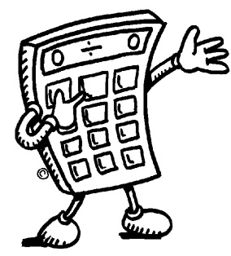

- If Janet had to resign from her job, would they be able to pay their bills? Explain your answer.


- Can you think of income/expenditure that has not been included in this budget? Make a list below.
