Suggested Resources

Novels/Novella(jct.ie):
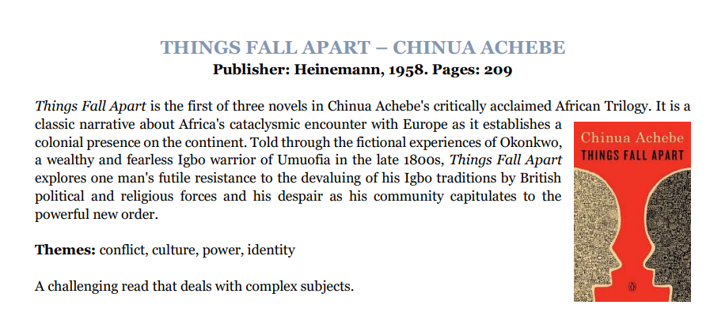
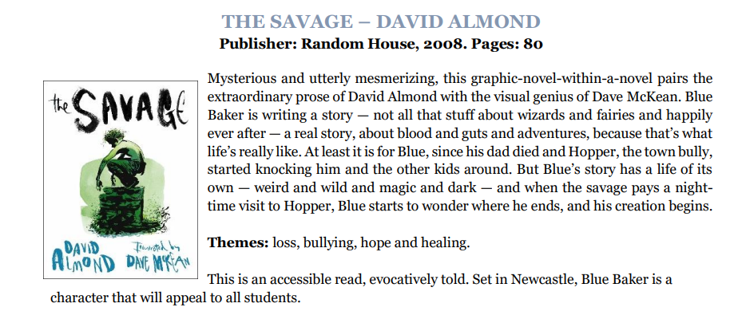

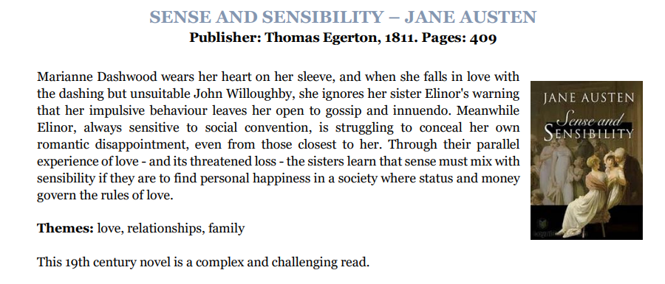
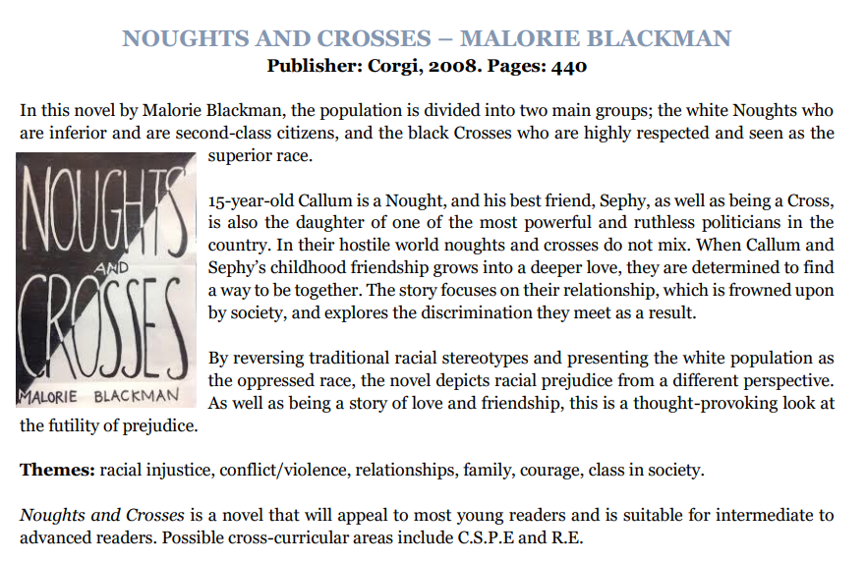

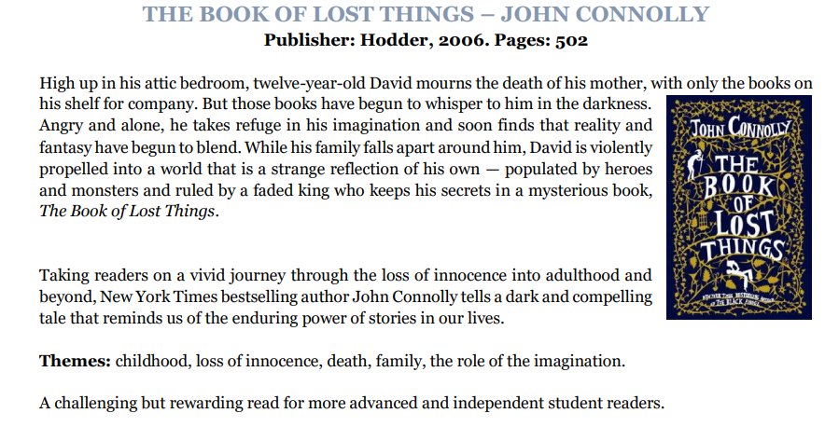

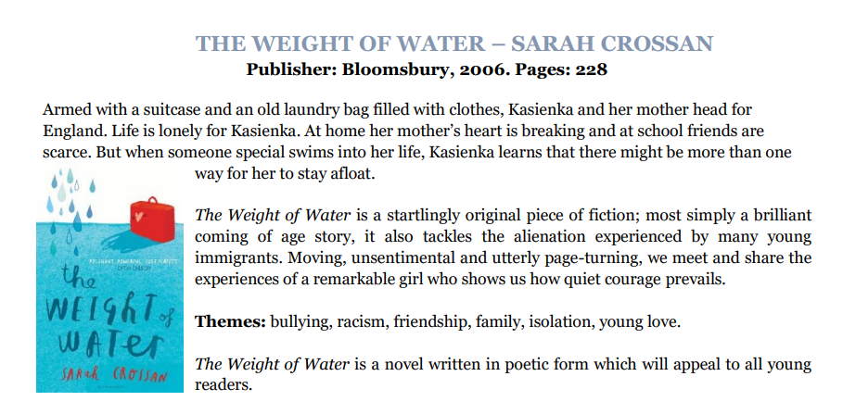

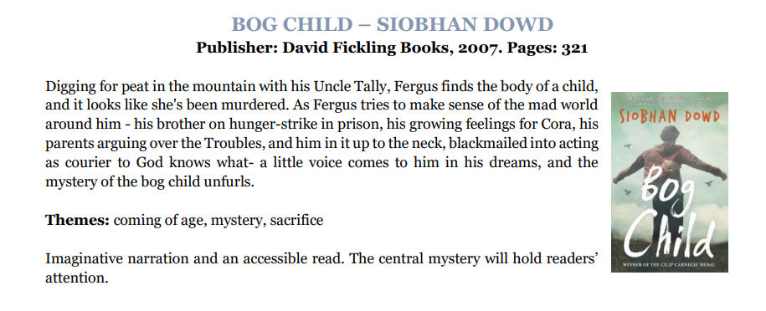
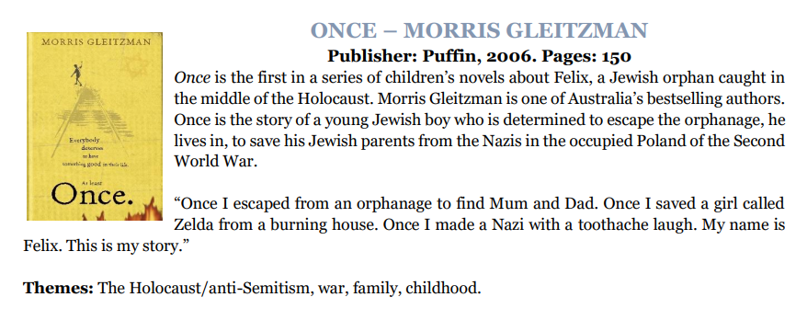
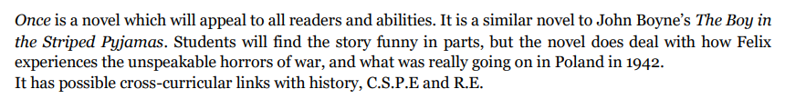
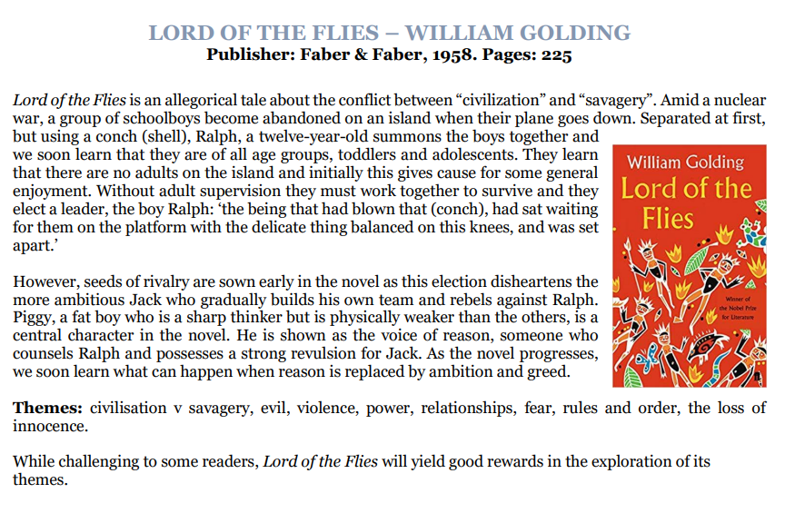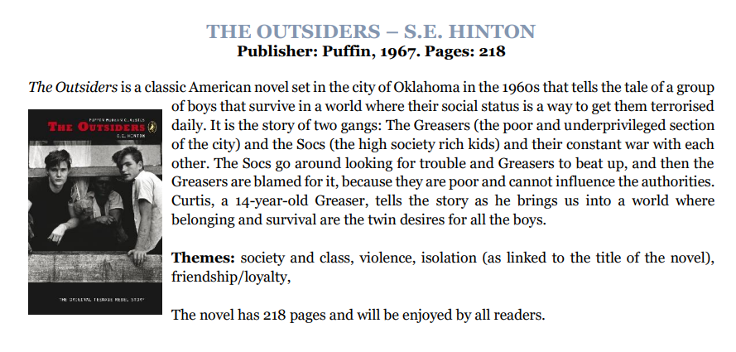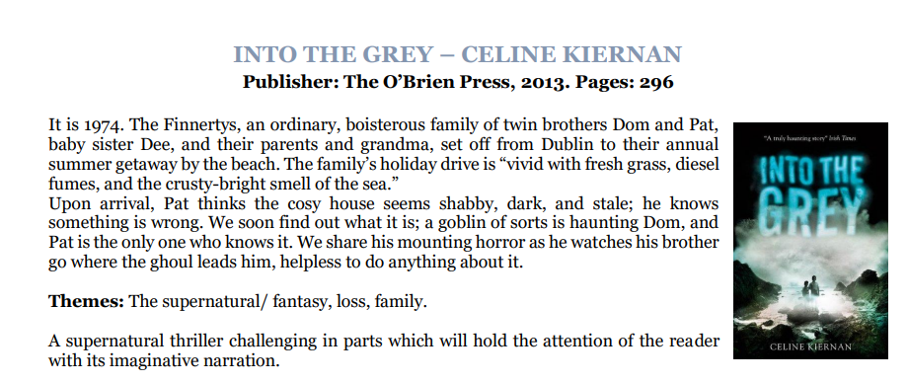
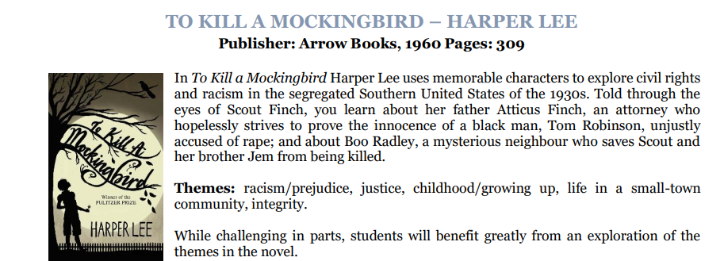

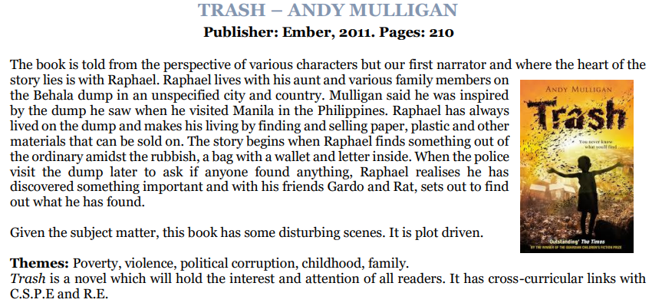
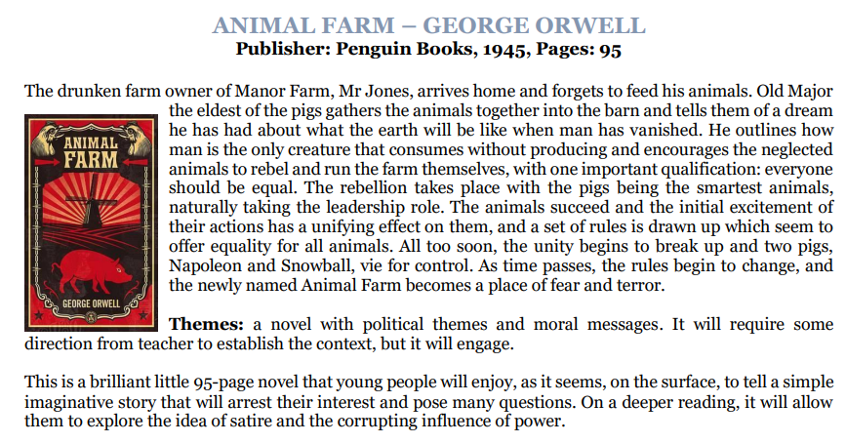

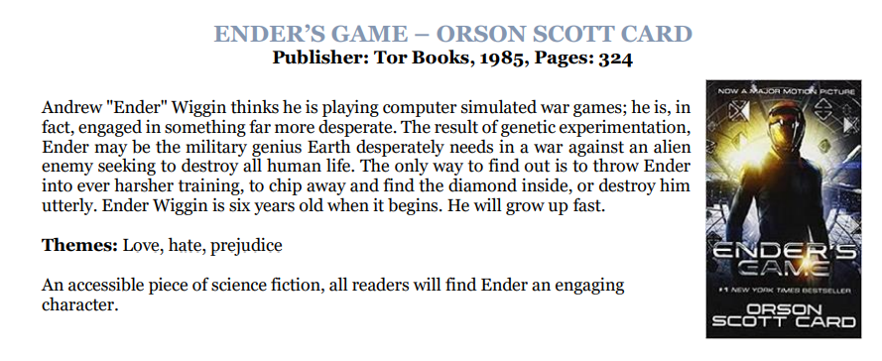
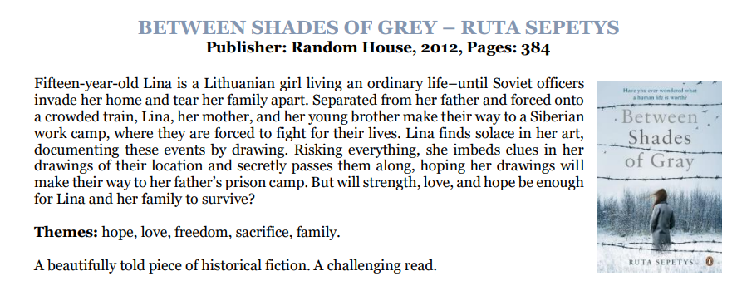

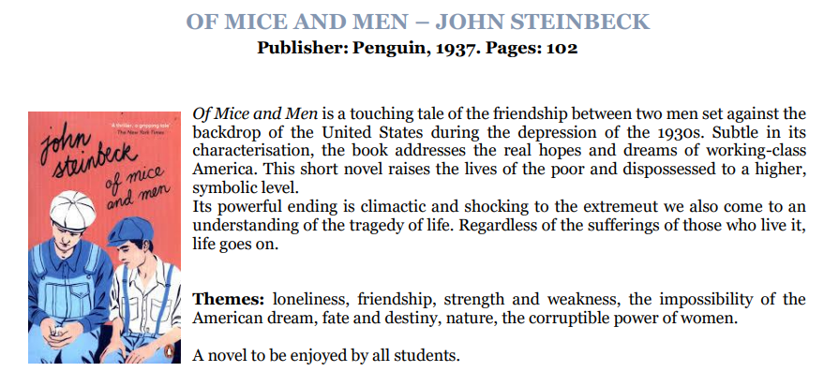
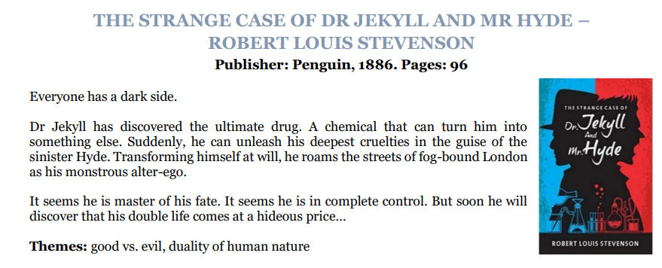
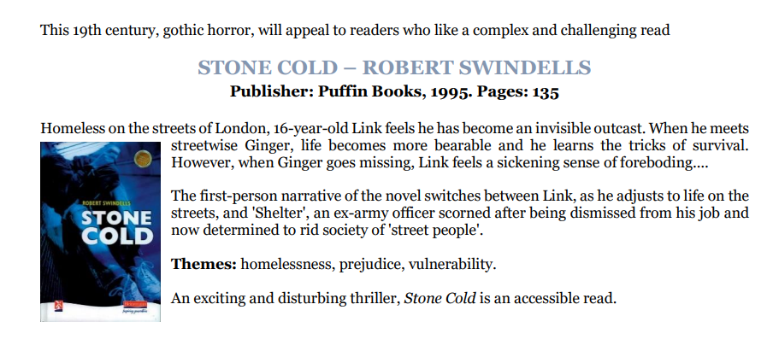
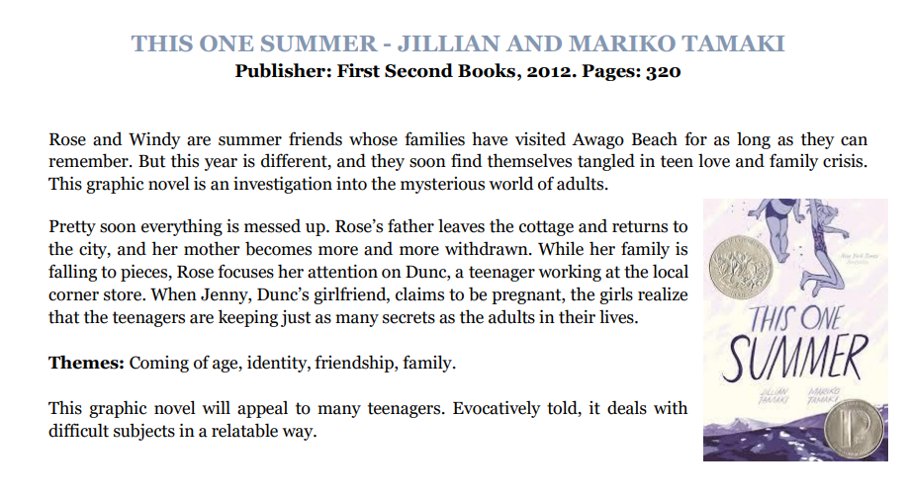

Drama(jct.ie):
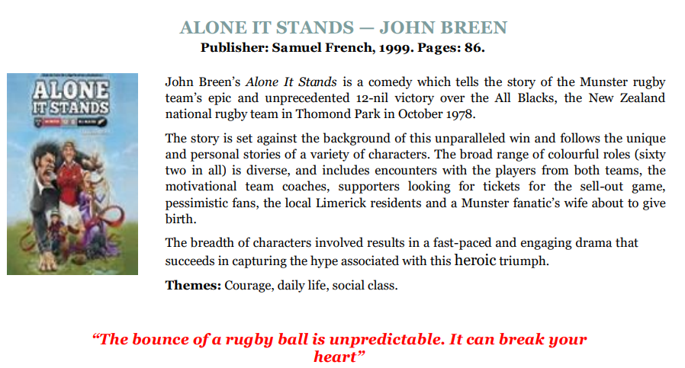

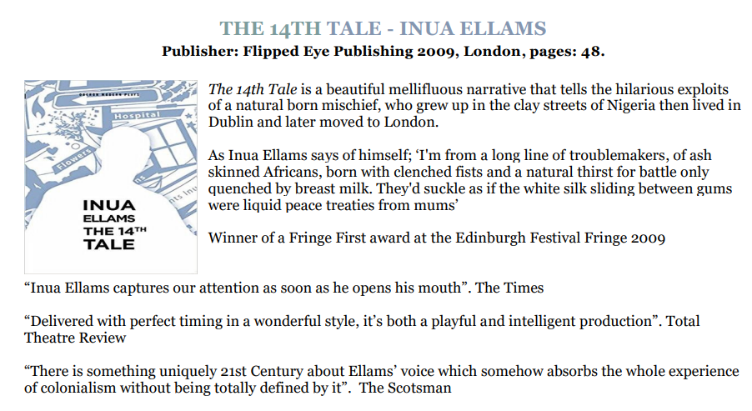

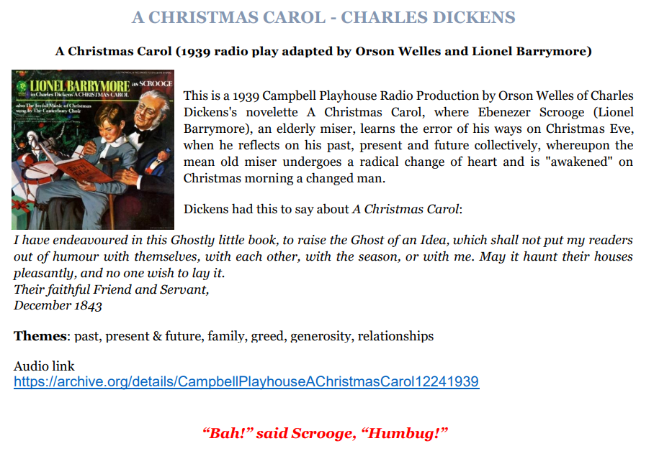

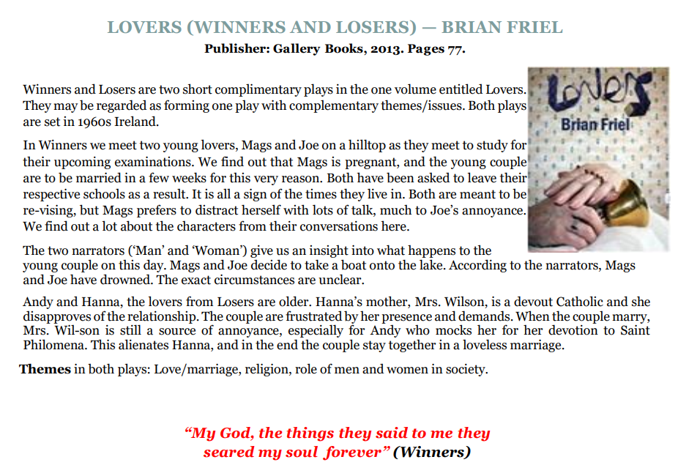

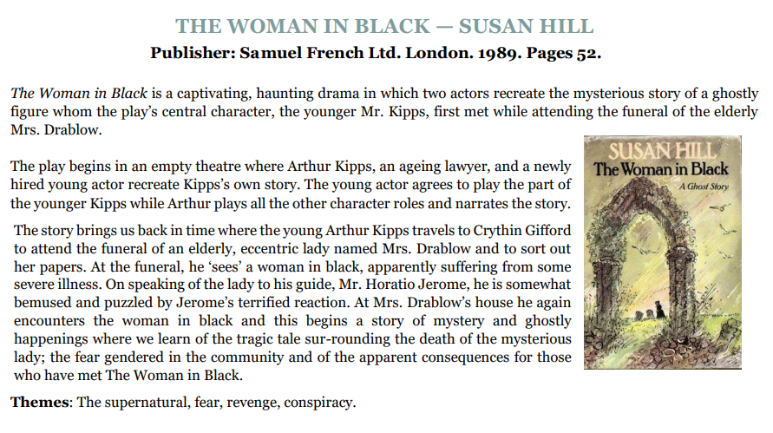
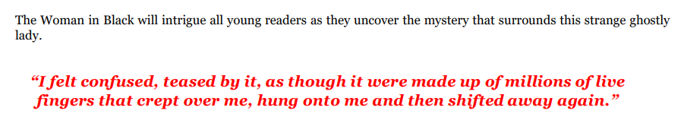

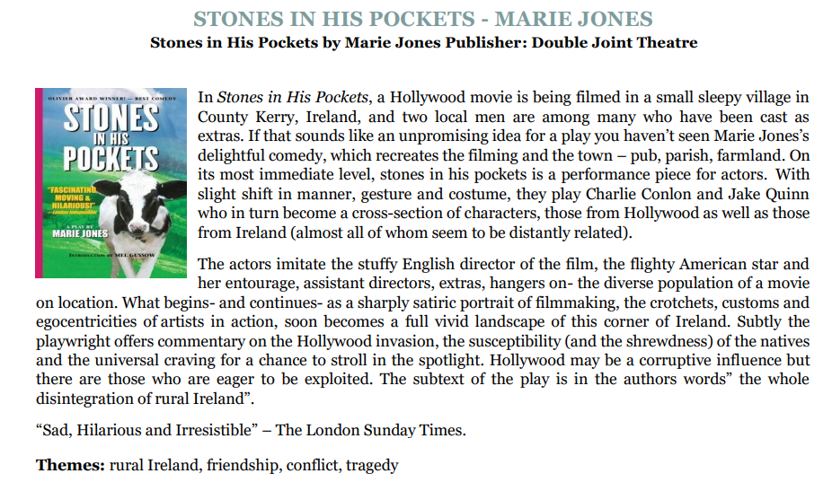

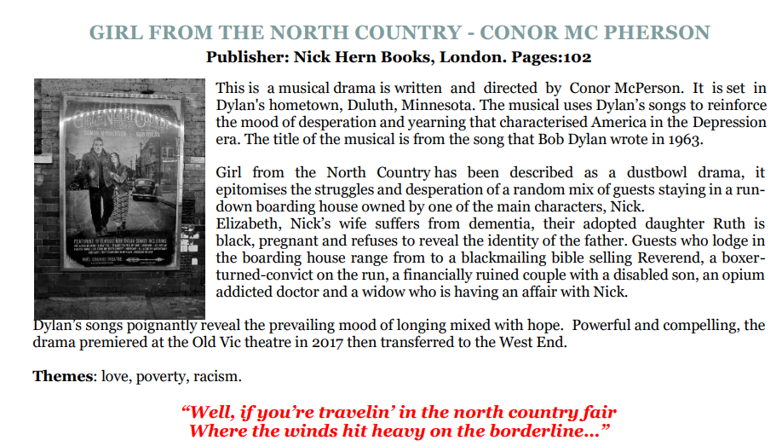

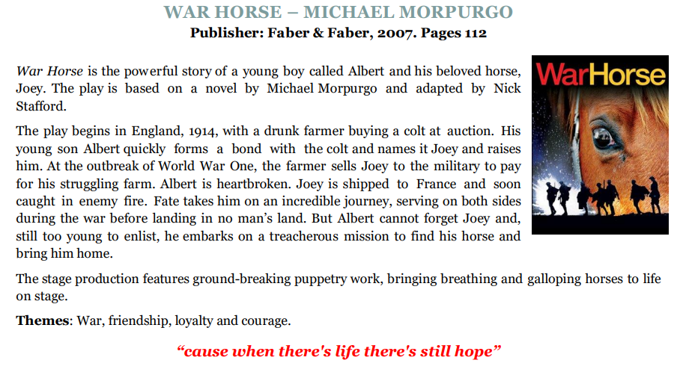

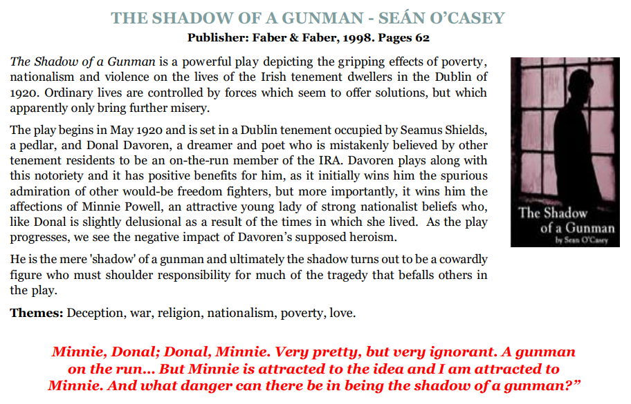

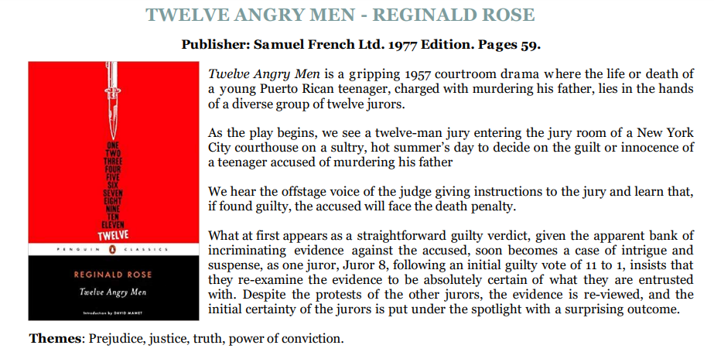
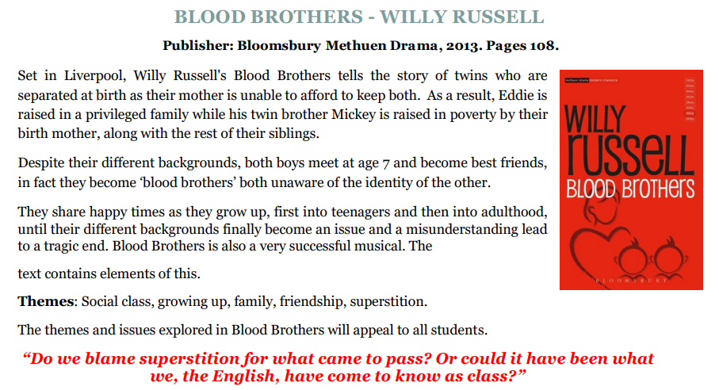

Poetry(jct.ie):
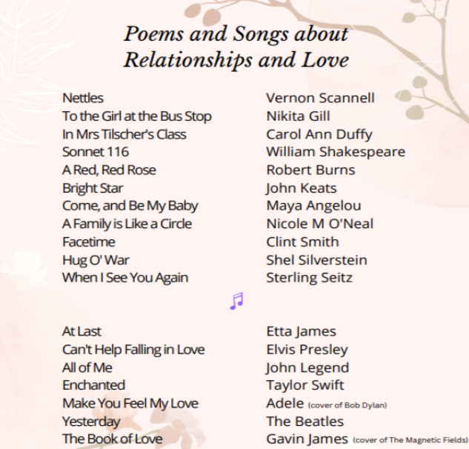
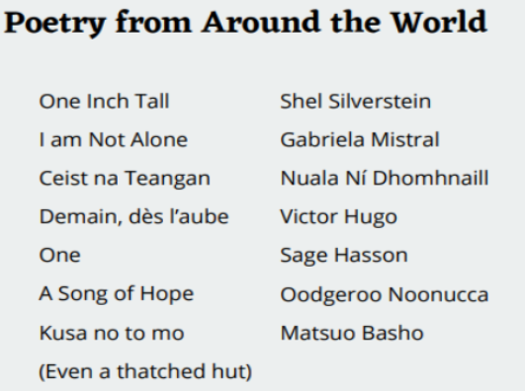
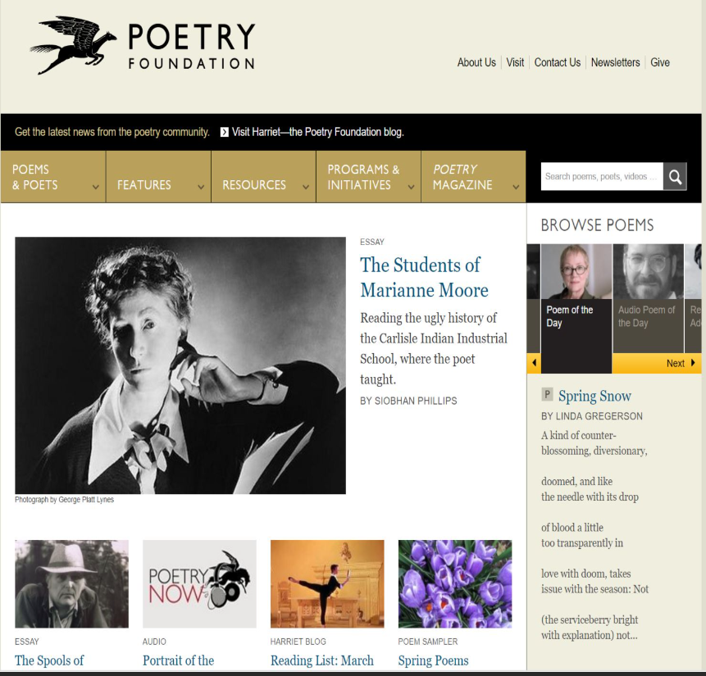

Pam Ayres: https://poetryarchive.org/poet/pam-ayres/

Academia of American Poets: https://poets.org/poem/wheatear

Poetry for Teens: https://poets.org/poetry-teens

Mindmap Apps/Software:

Lucidspark.com: https://lucid.app/pricing/lucidspark?km_CPC_AdGroupID=111001785536&utm_source=google&km_CPC_CampaignId=11277231974&km_CPC_MatchType=e&km_CPC_Country=1007893&km_CPC_Keyword=electronic+brainstorming&gclid=Cj0KCQjwsaqzBhDdARIsAK2gqndrAuaCsoA7lqO0t2w1i8IfhWkTRD5K9X62dEZEYqQ8aq_G75T6WJsaAovfEALw_wcB&km_CPC_Creative=470768413160&cq_cmp=11277231974&sessionDate=2024-06-13T13%3A08%3A07.524Z&km_CPC_TargetID=kwd-300836309214&referer=https%3A%2F%2Flucidspark.com%2F&gad_source=1&utm_medium=cpc&km_CPC_target=&km_CPC_Device=c&anonId=0.0d3edd6519011af4d0f&km_CPC_AdPosition=&km_CPC_ExtensionID=&km_CPC_Network=g&sessionId=0.a65c044819011af4d10&utm_campaign=_spark_en_tier1_mixed_search_strategic_exact_&km_CPC_placement=#/pricing/spark

Canva: https://www.canva.com/online-whiteboard/?utm_source=google_sem&utm_medium=cpc&utm_campaign=uk_en_all_seeding-product_whiteboard_lower_acq_mau-growth_bm&utm_adgroup=uk_en_all_seeding-product_mind-map_lower_acq_mau-growth_bm&utm_keyword=mind+map+free&gad_source=1&gclid=Cj0KCQjwsaqzBhDdARIsAK2gqndzxcosg9B5y-9dRQ0f2G61UBZ98xKD5-mCi6D-IkzTTcAm4dMBJicaArmCEALw_wcB&gclsrc=aw.ds

Resources:
