Task 1 File Management
MIMLO 5
5 marks
You are required to create a new folder structure for your Collection of Work.
This must comprise of a main folder and subfolders for tasks 2-6.
All files that are required for the Collection of Work must be saved in their relevant folder, with an appropriate filename.

Task 1 - FILE MANAGEMENT
Main folder and sub folders created with appropriate name | 1.00
Files for each task saved in correct subfolder with appropriate name and correct file type
Task 2 files - doc, PDF | 1.00
Task 3 files - doc and PDF | 1.00
Task 4 files – doc | 0.50
Task 5 files - template, doc, datafile, form letter, merged doc, labels | 1.50
Subtotal | 5.00

Task 2 Document Creation
MIMLO 2
7.5 marks

You are required to create the following two documents for your collection of work.
Each document must be saved with an appropriate filename and saved in the relevant folder in your folder structure from Task 1. Note: marks for saving are allocated to Task 1

Document 1 – CV
(May have cross curricular links with Work Experience/Practice)

- Create the attached CV. You may customise the content with your own details, qualifications, and experience. Do not delete any sections. 1.0 m
- Save as CV Sample (Task 1 - 0.5 m)
- You must use a right aligned tab set at 15.5 cm and leader dots, as shown. 1.0 m
- Format all text as Calibri, 12 pt,
except the name at the beginning, this should be 20 pt. 1.5 m
- Apply single line spacing 0.5 m
- Apply the Heading 1 style to each of the sub headings – Education, Experience, Hobbies and Interests, References 1.0 m
- Apply a simple top and bottom border to each of the sub headings – as shown in the sample 0.5 m
- Using format painter or otherwise, apply bold formatting as shown. 0.5 m
- Insert a page break before the Hobbies and Interests section 0.5 m
- Using the review tools available to you, check the documents for errors 0.5 m
- Print one copy of the document. Make sure to print single sided. 0.5 m
- Save a copy of the document as a PDF with the same file name (Task 1 - 0.5 m)

Jane Smith
123 Main Street, City, Country
Phone: (123) 456-7890
Email: jane.smith@example.com

Education
Bachelor of Arts in Business Administration Graduated: May 2023
University of XYZ, City, Country
Certificate in Business Administration Graduated: June 2019
College of FET

Experience
Administrative Assistant June 2023 – Present
ABC Corporation, City, Country
Managed office operations and administrative functions to ensure efficiency and productivity.
Coordinated meetings, appointments, and travel arrangements for executives.
Prepared and edited correspondence, reports, and presentations.

Office Intern January 2020 - May 2023
XYZ Solutions, City, Country
Assisted with daily office operations, including filing, data entry, and answering phones.
Supported the administrative team with various projects and tasks.

Hobbies and Interests
Snowboarding
Guitar
Theatre and Drama

References
Available upon request.

Task 3 Document Creation – Graphics
MIMLO 2
15 marks
You are required to recreate the poster shown here. You will insert and format shapes, text boxes, and images. The images will be available for you in the Class Materials folder in Teams.
The finished poster should look like this:
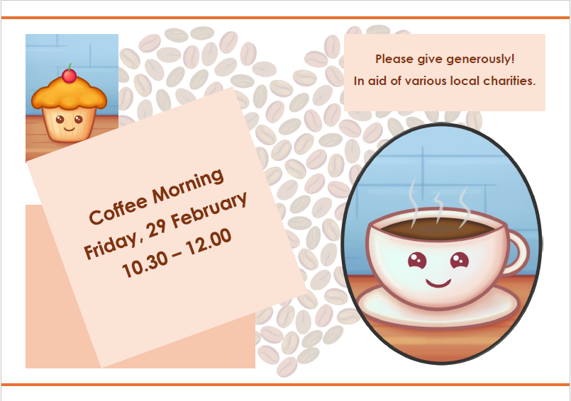
- Open a new blank document. Save as Coffee Morning Poster (Task 1 - 0.5 m)
- Change the orientation of the page to landscape. 0.25 m
- Apply a 3 pt orange line as a page border to the top and bottom of the page only
0.50 m
- Locate and download the graphic Heart provided to you. Apply this picture as a watermark. 0.25 m
- Locate and download the graphic Coffee provided to you. Insert this picture into the document. 0.50 m
- Resize the picture to 12 cm in height. 0.50 m
- Crop the picture so that it looks like the image below: 0.50 m

- Select the picture and apply an oval border style like the one shown below:
Using your Format Picture options, make sure there is no shadow on the picture.
1.0 m
- Position the picture in the bottom right of the page. 0.50 m
- Insert a text box on the page. Resize this so that it is a square with sides of 11.5 cm. Type the following in the text box: 1.00 m
Coffee Morning
Friday, 29 February
10.30 – 12.00
- Format this text as Century Gothic, bold, 28 pt. And align it centrally both horizontally and vertically within the text box. 1.25 m
- Format the text box as follows: fill with a light orange colour and no outline 0.50 m
- Rotate the text box 20$°$ to the left (340$°$) and position it in the bottom left of the page. 1.00 m
- Insert a second text box on the page with the same fill and outline as the first text box. 1.00 m
- Resize it to 4 cm in height and 10.5 cm in width. 0.50 m
- Type the following in the text box
Please give generously!
In aid of various local charities.
- Format this text as Century Gothic, bold, 18 pt. And align it centrally both horizontally and vertically within the text box. 1.25 m
- Insert a rectangle on the page. Resize the box so that it is 8.5 cm in height and 12 cm wide. 1.00 m
- Position it in the bottom left of the page. And send it behind the text box. 1.00 m

- Insert the picture coffee again, and crop it so that it looks like the image below:
1.00 m
- Resize this picture to 6.7 cm in height. 0.50 m
- Position it in the top left of the page and send it behind the text box. 1.00 m
- Save a copy of it as a PDF file. (Task 1 - 0.5 m)

Task 4 Document Creation – Tables
MIMLO 2
10 marks
- Open a new blank Word document. Save as Pool Activities (Task 1 - 0.5 m)
- Recreate the following table: 0.5 m

Activity | Age Group | Time | Price
Aquafit | Adults | 14:00-15:00 | €7.50
Intermediate Lessons | Adults | 19:00-20:00 | €8.00
Beginner Lessons | Adults | 17:00-18:00 | €8.00
Swim Club | Under 7s | 16:00-16:45 | €3.00
Swim Club | 7-10s | 16:45-17:30 | €5.00
Swim Club | 11-15s | 17:30-19:00 | €5.00

- All text is Times New Roman, 12 pt, except the first row which is Georgia, 12 pt, bold 1.0 m
- Apply alignments as shown. 0.5 m
- Autofit the table to its contents. 1.0 m
- Insert a new column between Age Group and Time to contain the following information: 0.5 m
Day
Monday
Wednesday
Saturday
Tuesday
Tuesday
Tuesday
- Resize all rows so that they are 0.75 cm in height. 1.0 m
- Resize the Age Group column so that the width is 5 cm. 1.0 m
- Apply a 3 pt green border to the outside borders and to the bottom border of the first row. All other inside borders to remain the default ½pt black. 1.0 m
- Apply light blue shading to the first row of the table. 0.5 m
- Sort rows 2-7 in ascending order of the Activity. 1.0 m
- Merge the cells that contain ‘Swim Club’, delete the extra ‘Swim Club’s only one should be displayed in the cell. 1.0 m
- Centre the table on the page horizontally and vertically. 1.0 m

Task 5 Additional Resources/Features
MIMLO 4
15 marks
(Explore vocational area and any cross curricular links when deciding which additional features to assess)

Feature 1 – Template
Create a template for the letterhead for the Greenfield Community Group, as shown on the attached page.
This letterhead will be used any time an official letter is sent from the community group, or any time a notice is printed for the group.

Open a new blank document
- Ensure the page size is A4
- Change the margins to the Moderate setting.
- Click into the header and type the name of the group and the address. Format as Bookman Old Style, 26 pt and 12 pt. Centre align.
- Change to the footer and type the text as shown. Bookman Old Style, 10 pt. Centre align.
- Using paragraph borders, insert a bottom border in the header where shown, and a top border in the footer.
- Close the header and footer to set up the formatting for the document.
- Format the entire document (excluding the header and footer) as Garamond, 12 pt, single line spacing, 0pt spacing before and after paragraphs.
- Save this as a Word Template with the file name Letterhead in the relevant folder
- Close the template.

- Open a new document based on your Letterhead template.
- Type a letter to the members of the group’s committee to let them know that there will be a committee meeting on Saturday 23 March, at 8 pm, in the Community Centre, for all committee members. (You need to come up with some more text for this letter!)
Use your own name as signatory for the letter.
- Save this letter as March Meeting Notice

Feature 2 – Mail Merge and Labels

(May have cross curricular links with Database Methods module – can use Microsoft Access as the datafile source)

- Create a datafile using appropriate field names for the following customer details:
Save this datafile as Insurance Customers
Ms Karen O Shea | Mr Liam Murphy | Mrs Niamh Byrne | Mr Conor O Neill | Dr Saoirse Greene
12 Oakwood Drive,  Rathmines,  Dublin 6 | 45 Seaview Avenue,  Blackrock,  Co Cork | 78 Willow Park,  Salthill,  Galway | 23 Castle Street, Kilkenny | 56 Riverbank Road,  Limerick
HOM-2025-012 | CAR-2025-234 | HOM-2025-123 | CAR-2025-235 | CAR-2025-236
house | car | house | car | car
€940.00 | €310.00 | €690.00 | €490.00 | €780.00

- Type the attached letter to merge with the datafile, inserting merge fields where shown. Save this letter as Insurance Form Letter
- Use the Insert date function to insert today’s date in the indicated place. Ensure the date updates automatically
- Format as Arial, 12 pt.
- Apply single line spacing, 0 pt before and after paragraphs.
- Merge this letter with the Insurance Customers datafile to create a new document, save this document as Merged Letters.
- Create a set of address labels for Car insurance customers only. Use an Avery A4/A5 Label, product code L7160. Save this as Car Customer Labels.
- Sort the labels on the basis of Surname.
- Print the Car Customer Labels displaying the recipients (not the merge fields).
ABC Insurances
NewTown
Co Wexford

<<Full Name and Full Address>>

Ref: <<Policy No>>

Insert today’s date here

Dear <<Title>> <<Last Name>>

The above policy is due for renewal next month. Our very competitive quote for your <<Type>> insurance is <<Quote>>. You can choose to renew your policy online, or contact us directly to discuss the policy renewal.

We look forward to covering your insurance needs in 20##.

Your sincerely

_______________________________
Type your name here

Task 6 PRIMARY FUNCTIONS & PROCESSES
MIMLO 1
5 marks

You are required to illustrate your knowledge of the features, functions, and processes of the word processing application. This task can be submitted as a Word document, a PowerPoint presentation, an audio file, etc. The presentation to the class will also be recorded.

For this task you must describe the features and functions that you have used throughout this collection of work.
Choose two of the following headings as your topics for this task
- File management
- Character formatting
- Paragraph formatting
- Page setup
- Graphics – pictures, shapes, SmartArt, etc
- Tables
- Review tools

Present/demonstrate to the class your understanding of the features. Include where you have applied them throughout Tasks 1- 5.
Save any relevant files with a suitable file names in the relevant folder.
You must submit any notes/demonstration documents prior to the presentations.

Task 7 FILE MANAGEMENT 2
MIMLO 5
2.5 marks
When you have completed Tasks 1 – 6, create a copy of the folder structure that you created in Task 1. Rename this copied folder as Task 7
Locate the Pool Activities PDF file and rename this as Pool Schedule.
Select the folder that you created for Task 3 and delete it.
Move the folder that you created for Task 6 into the folder that you created for Task 5/ make the folder that you created for Task 6 a subfolder of the folder that you created for Task 5
Sort the files in the Task 2 folder by the size of the file

Sources of Content:
Task 2 CV content AI generated
Task 3 Images
https://pixabay.com/vectors/love-heart-romance-passion-1759139/
https://pixabay.com/illustrations/breakfast-muffin-coffee-drink-6299000/
Task 5
Data for datafile – AI generated

